**Testing Document for Formal Programming Assignment (Python)**

In order to ensure that my program works correctly, I will execute a total of three program tests. In all three tests I will record the input (and the reason for the particular input), the expected output, the actual program output, and whether the program pass or failed the test.

**Test #1**

**Input:**

* Haircut = 20
* Amt tendered = 20
* Coupon = 3
* Company name = Jeremy’s Clips
* Coupon receipt value = 2
* Coupon receipt valid until = 7/7/17

**Expected Output:**

I expect the program to output:

* Subtotal $17.0
* Total $19.21
* Amt Tendered $20
* Change $0.79
* Thank you for choosing Jeremy’s Clips!
* $2 NOT VALID WITH OTHER OFFERS
* Coupon valid until 7/7/17

**Actual Output:**

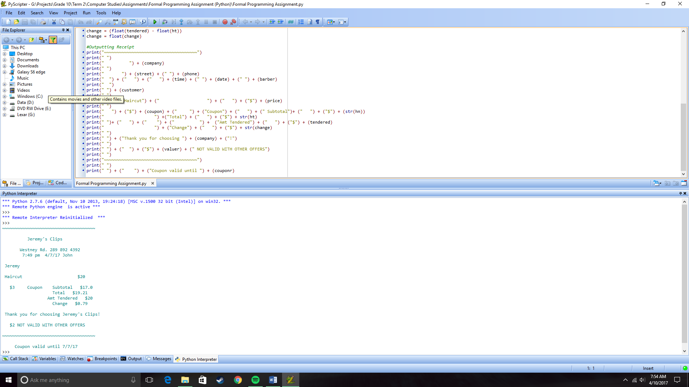

**Results:** Since the program calculated the total properly and displayed the infromation on the receipt, the program **passed** this test.

**Test #2**

**Input:**

* Haircut = 28
* Amt tendered = 30
* Coupon = 15
* Company name = Great Clips
* Coupon receipt value = 4
* Coupon receipt valid until = 8/7/17

**Expected Output:**

I expect the program to output:

* Subtotal $13.0
* Total $14.69
* Amt Tendered $30
* Change $15.31
* Thank you for choosing Great Clips!
* $4 NOT VALID WITH OTHER OFFERS
* Coupon valid until 8/7/17

**Actual Output:**

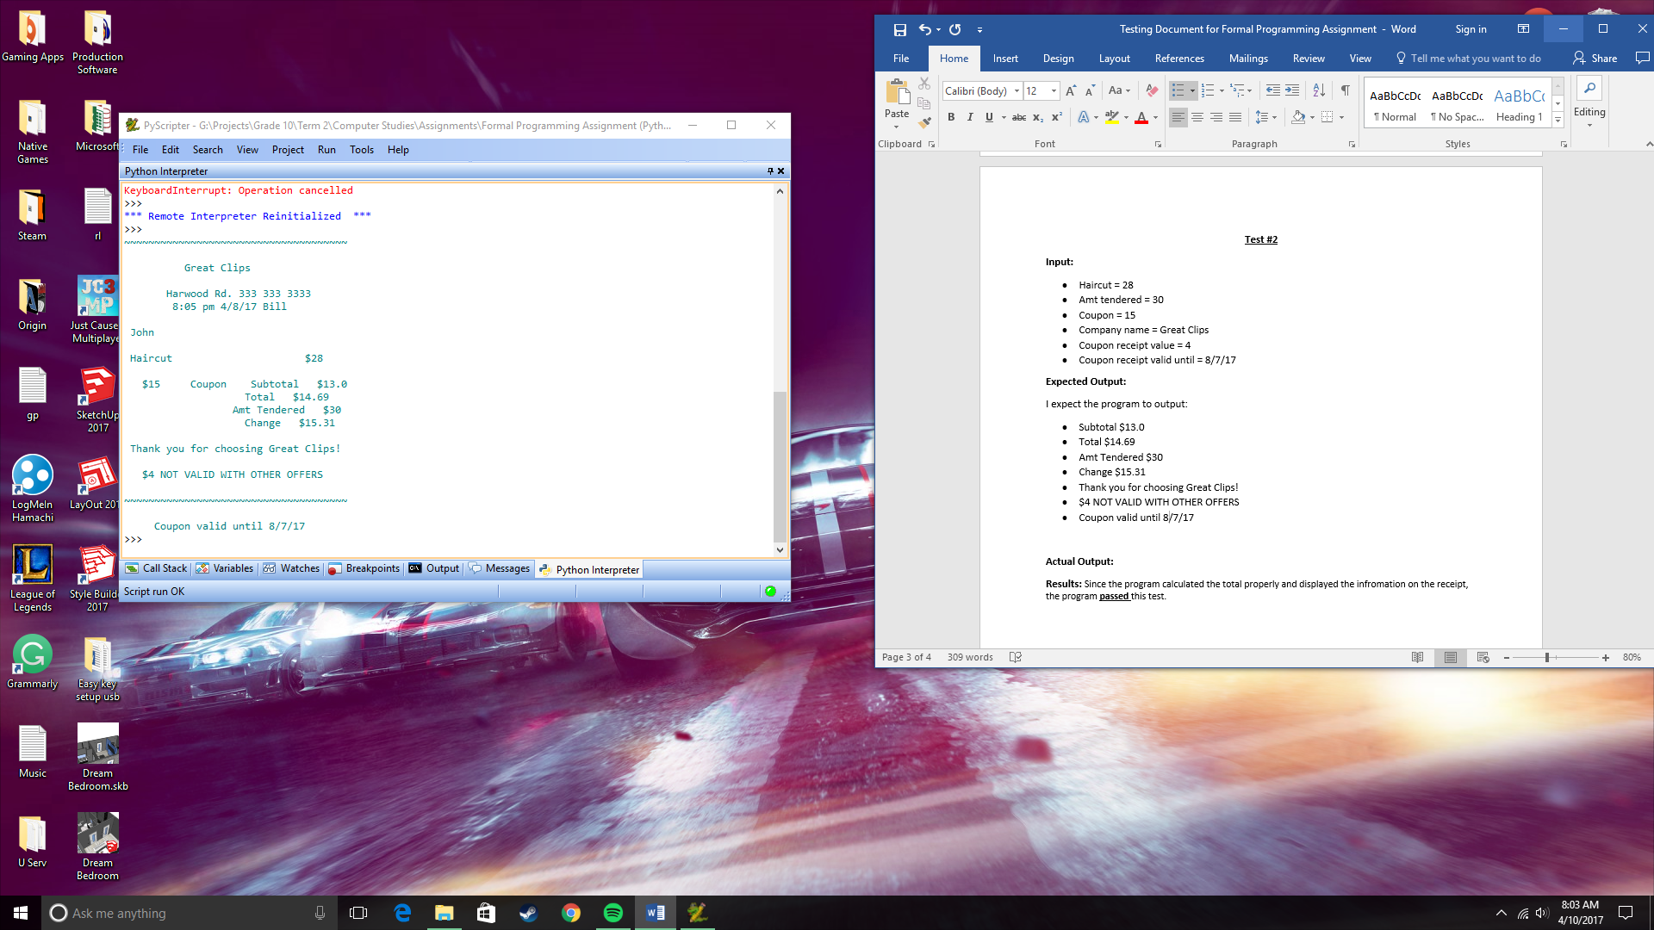

**Results:** Since the program calculated the total properly and displayed the infromation on the receipt, the program **passed** this test.

**Test #3**

**Input:**

* Haircut = 16.99
* Amt tendered = 20
* Coupon = 1
* Company name = First Choice
* Coupon receipt value = 3
* Coupon receipt valid until = 8/7/88

**Expected Output:**

I expect the program to output:

* Subtotal $15.99
* Total $18.0687
* Amt Tendered $20
* Change $1.9313
* Thank you for choosing First Choice!
* $3 NOT VALID WITH OTHER OFFERS
* Coupon valid until 8/7/88

**Actual Output:**

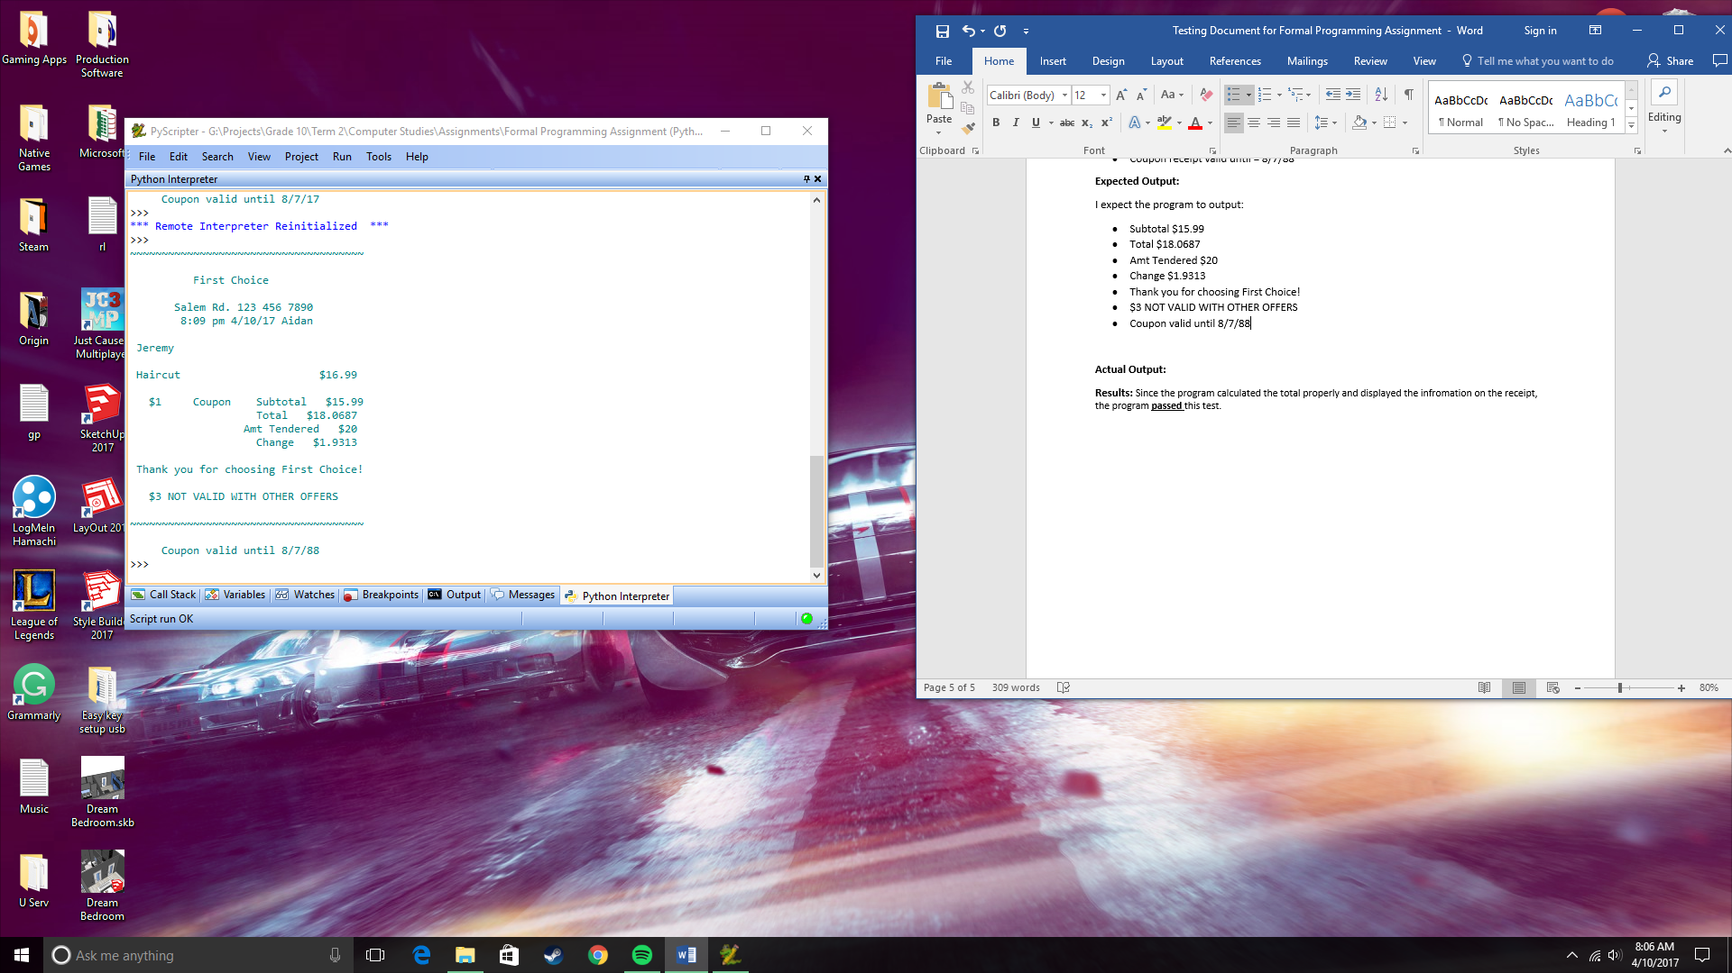

**Results:** Since the program calculated the total properly and displayed the infromation on the receipt, the program **passed** this test.